Please insert your title here (the title should be brief and informative not exceeding two lines: ca. 100 characters, 16 pt)
Presenting Author¹, Name Surname¹, Name Surname^{1,2}
¹ First author affiliation, City, Country.
² Second author affiliation, City, Country.
E-mail: presenting.author@affiliation.domain
Keywords: provide four keywords separated by commas.
This is the main text of the abstract. Please paste your abstract text here. Use justified alignment of the text and single-spaced paragraphs in 12 pt Times New Roman. Do not change any of the formatting settings in this template file!
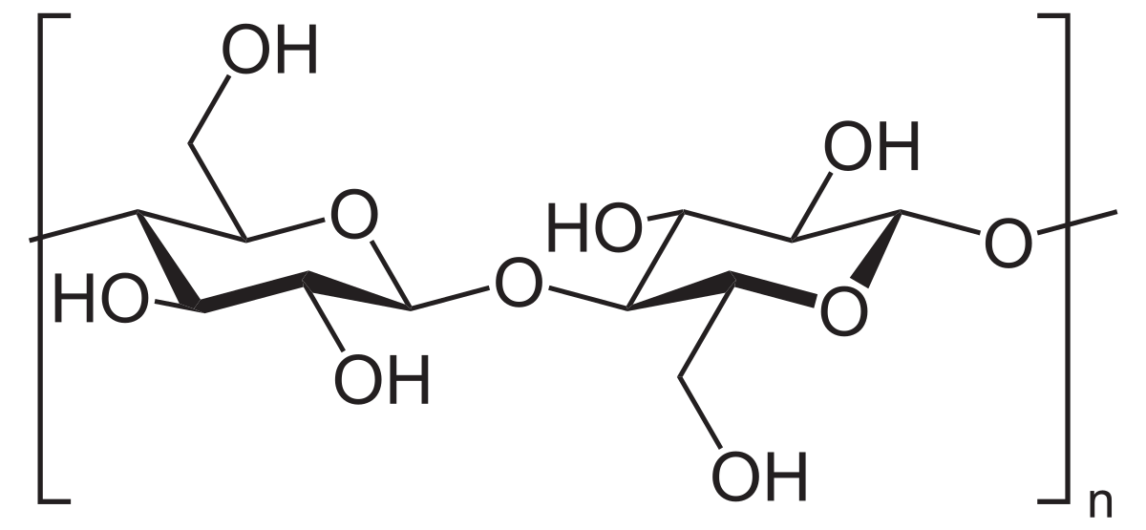
For Figures, give a concise caption (11 pt). Figures will be shown in color in electronic versions of the abstracts. If you choose to submit color figures, it is your responsibility to ensure that the figures are easy to read and understand even when printed in grayscale mode. Ensure 300 dpi resolution for figures, and pay attention to keeping file size small to avoid producing an oversized final PDF abstract file.
Figure 1. Avoid using floating figures. Use center alignment for the figure, and left alignment for the caption (11 pt). Use bold font to label the figure and number only.
References in the text should be given by numbers in square brackets [1]. The list of references (11 pt) follows the last line of the text with one extra line inserted. Follow the style of the Journal of the American Chemical Society.
Abstracts are limited to one page only. Keep the .doc Extension (Office Word) when saving your file for electronic submission via the conference website.
The abstracts will be reviewed and selected for the type of presentation. The presenting author will be informed about the decision by the deadline published on the conference website. Accepted abstracts will be published in the Abstract Book of the CBM13 conference. Abstract and author names will be published exactly as submitted. No changes will be accepted after abstract submission.

________________
[1] Author N.; Author N.; Author N.N. Journal Year, Volume, Inclusive–Pagination.
[2] Author N.; Author N.; Author N.N. Journal Year, Volume, Inclusive–Pagination.

